YEAR 12
GEOGRAPHY
HOME LEARNING KIT
WEEK 1

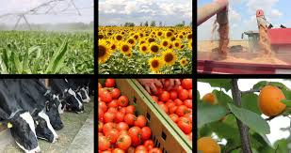

NAME
LEVEL
S/ID

Lesson # 44
Strand : Human Geography
Sub strand : Agriculture and Food Supply
Learning Outcome: Examine the importance of agriculture
Agriculture means the cultivation of plants and animals for human use and purposes.
“the science and practice of cultivating for food and keeping or breeding animals for food”

The use of land in Fiji is influenced by a combination of factors such as physical and cultural factors. Physical factors include relief, climate and soil whilesocial and cultural factors include people’s use of the land (Individual farmers), land ownership and land tenure, transport availability and access to markets, marketing methods, and capital available for development and improvement, market demands and prices.

COMMERCIAL FARMING
The major commercial crops grown in Fiji are Sugarcane, Copra, Ginger, and Rice, although some are not exported but they are consumed locally and are sold in the local market
SUBSISTENCE FARMING - Growing food for own use
Resource study Activity
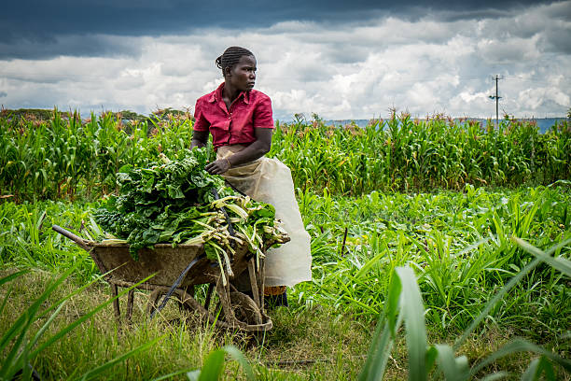
- State two advantages of subsistence farming during the crisis like CORONA VIRUS.
- Describe one way in which the government can ensure food security.
- Name few of Fiji commercial agricultural markets. State how Fiji can build better relationships in terms of trading

Lesson # 45
Strand : Human Geography
Sub strand : Agriculture and Food Supply
Learning Outcome: Examine the importance of agriculture

Agroforestry
- Is the farming and retaining parts of the forest.
- Agriculture incorporating the cultivation of the trees.

Advantages of Agroforestry
- It ensures forest cover is protected and maintained.
- It conserves and protects the soil.
- Improved soil quality
- Control runoff and soil erosion – reducing losses of water and soil materrial
- Crops cultivated are protected and sheltered from strong winds eg. During cyclones
- Increased crop production and economic gain

ACTIVITY
Describe the following examples in your own words
Some Examples of Agroforestry Practices
- Silvopasture: combine trees with forage and livestock production.
- Inter-cropping
- Polyculture
- Crop rotation
- Strip cropping
- Contour planting
- Fallowing
- Mulching

Lesson # 46
Strand: Human Geography
Sub Strand: Agriculture and Food Supply (Fiji)
Learning Outcome: Describe how physical factors affects agriculture.
Physical factors
- Relief and slope
  - Whether the land is high, hilly and rocky or low, flat lands and big plains it will influence the type of crop grown there and how successful a farmer is in utilizing this land.
  - Whether it is close or far from the water sources or rivers
- Climate
  - The amount of rainfall and solar radiation it receives
  - Regularity(how often rain-falls)
  - Seasonal distribution of rainfall (winter and summer)
- Soil Characteristics
  - Red dry and leached soil or dark, humid, rich and alluvial soil.
- Temperature-warm and cool
- Other factors • Sunshine hours.
  - Hurricanes
  - Floods
  - Other climatic extremes

Activity
- Explain one way in which climate affects agriculture.

- State two ways in which soil boost agriculture.

- Describe one way in which natural disasters affect agriculture in Fiji.

Lesson # 47
Strand: Human Geography
Sub strand: Agriculture and Food Supply (Fiji)
Learning Outcome: Describe how cultural and social factors affects agriculture.

Cultural and Social Factors
- Individual farmers
  - This depends on the farmer’s needs, skill and experience
- Land ownership and type of tenure
  - Lease or Freehold
- Transport Availability and Access to Markets-
  - how good are the services by roads, railway, boats and air transport and how near or far the markets are
- Marketing Methods
  - cooperatives
  - contracts
  - sale to middlemen
- Capital Available for Development and Improvement
  - source of credit and rates if interest(e.g. bank loans)-
- Market Demands and Prices
  - how much is needed and can be sold to make profits

Activity
- State one way in which landownership has affected agriculture in Fiji.

- Describe how market demands affects the agriculture.

- State two ways to improve the production in agriculture sector in Fiji.

Lesson # 48
Strand: Human Geography
Sub strand: Agriculture and Food Supply (Fiji)
Learning Outcome: Discuss the importance of farming types in the economy.
Importance of Agriculture
Environmental | Economic | Social
- Retention of vegetation  - This is essential to retain soil cover.  - It also prevents soil erosion and retains to some extent the microclimate of that particular area.  - Retains the biodiversity  - Retains the biodiversity to some extent such as to retain the food chains and food web of specific areas, thus saving most of the organisms from being extinct in a particular area.  - Retains soil cycles  - The presence of plants means humus for the soil which contributes to the nutrient cycles and other soil cycles.  - Retains soil fertility  - Vegetation does not only retain soil cycles; it also retains all the elements which make up the whole soil composition.  - It also prevents soil erosion. | - Source of income/livelihood  - it promotes employment  - wealth to provide for their daily needs and wants.  - Promotes investments  - as demands continue to vary there would continue to be an increase in investment opportunities  - as population grows the market continues to expand.  - Increases Government Revenue and GDP  - as commercial agriculture increases the GDP of the country also increases which means the increase in Government Revenue (especially due to export earnings).  - Multiplier Effect  - earnings from agricultural sales have multiplying effects in a country.  - That is, from the revenue earned by the government which promotes development and economic growth to the earnings of a simple farmer which provides for his livelihood and social obligations. | - Source of fresh daily food  - provide fresh food to the farmers family and to consumers  - Source of healthy diet  - it provides food from all the food groups hence it provides healthy diets to the farmer and the consumers.  - Promotes development  - it will mean infrastructural development, technical and financial assistance provided by the government; development initiated by the farmer; and development created by other investors and services which are either drawn into or decentralized into these farming areas.  - Food security  - finally, the growth of the agriculture sector would mean food security for the people.

Activity
- State two economic importance of agriculture to Fiji.

- Describe one way in which agriculture helps in biodiversity.

- State one way to increase food security in Fiji.

- Resource Interpretation

Role of Agriculture in Rural Development
The concept of rural development with reference to agriculture depends more on how rural families can survive off agriculture. There’s been an increasing emphasis on several rural development projects and programs and the recognition of rural areas that need more development.
More than half of the world’s population come from underdeveloped and developing countries. And a vast majority of that population lives in rural areas. Furthermore, this population depends mostly on some form of agriculture for their livelihoods.
These people have had very little to no benefits from modern technology.
Agriculture’s essential role is one of production, both for food and other raw materials for the rural and urban populations. The land is a basic resource for agriculture, and rural or developing areas have lots of it. The exploitation of this resource has helped families in rural areas turn agriculture into a revenue source and develop.

- State two ways rural dwellers can benefit from agriculture.
- With reference to Fiji, state how villages and rural settlements depend on agriculture for their livelihood. Support your answers with examples.

