WEEK 2 -ENGLISH – YEAR 12 WORKSHEETS

LESSON 48
Strand – Reading and Viewing
Substrand – Language Feature – IDIOMS
Learning Outcome – have a sound idea about idioms
- read each sentence and be able to choose the idiom suitable for each.
What is an Idiom?
- It is an expression in which words do not have literal meaning.
- Example: If I say I heard something through grapevine, it doesn’t mean I press my ear to an actual grapevine! I mean, I heard a piece of gossip
- Idioms are often funny and they may be quite poetic.
Other Examples:
- a bad apple – This refers to a person who creates problems. We often use this if a person’s behaviour has a negative influence on others. Eg. Frank was expelled from school because his teacher said that he was a bad apple.
- Beat around the bush – This means to talk a lot about unimportant things; to avoid talking about the thing that’s really important.
Eg. Tomasi don’t beat around the bush and tell me what the problem is!

Fill in the blanks with phrases from the box. Each phrase can be used only once.

1. "I'm feeling a bit ______. I need to go home and get some rest," said Bill's secretary.

2."I can't remember the mugger's face. It all happened in a ______," said the woman who was robbed at gunpoint.

3.The look on Cook's face tells me that he has something ______.

4.The test was ______ but I still couldn't score full marks for it.

5."Come on, men. We need all the help we can get as ______," said the village chief as he led the men in the direction of the broken bridge.

6.When I was in school, I was the ______. That's why I was always elected as the class monitor.

7.After marriage, the young bride began to show her ______ and started demanding expensive things from her husband.

8."Are we ______ yet ?" Roger asked his lookout, nervously.

9."I think it is time to ______ and tell Boyle who the car is really for," said Mrs. Simpson to her husband.

10.Carl's parents had to ______ for his medical degree but instead of studying hard, he was partying away with his mates

LESSON 49
Strand – Reading and Viewing
Substrand – Language Feature and Rules – AFFIXES/ PREFIX/ SUFFIX
Learning Outcome – know each concept well.

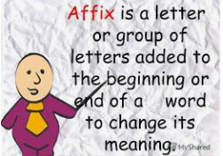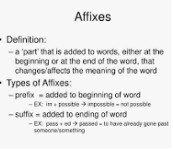

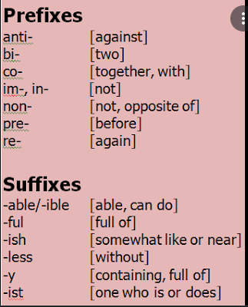

Part 1 – Prefixes
In the sentences below complete each word with a prefix chosen from the following list.
re- post- over- pre- super-

1. We hope the bus won’t be crowded.

2. Do you think the Mayor will be elected for a second time?

3. After he got a Ph.D. in Chemistry, he did doctoral work at Oxford University.

4. He took cautions against burglary by installing an alarm.

5. The tourist guide promised the tourists that they would get a fund if they did not like
the trip.

6. He added a script at the end of the letter.
7. The sonic plane flies from New York to Paris in
two hours and forty minutes.

Part 2- Suffixes
Use the correct suffix for the words in brackets
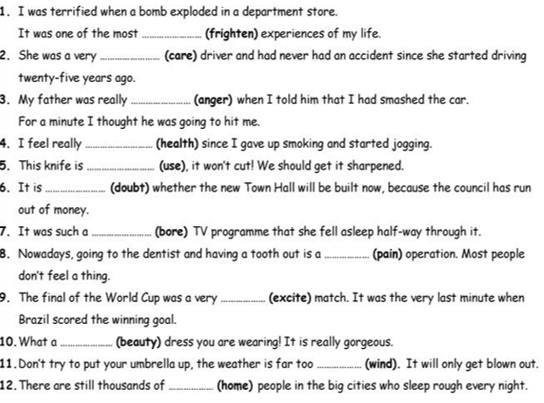

LESSON 50
Strand – Reading and Viewing
Sub-strand – Literature Feature – Short Story “THE GIFT OF THE MAGI
Learning Outcome – read and get to know the story

Read the short story “ The Gift of the Magi”.
A copy of the short story is provided in the home based package, read and analyze through accordingly.

Short Story 3
Theme: Value
Title: The Gift of Magi
Author: O. Henry
Setting: In a shabby condition in any society

Summary
The story is about Della and Jim Dillingham Young. They were very poor. Della is worried as she has $1.87 to buy a gift for Jim, a Christmas gift. Both of them do not have enough money to buy a gift for each other. Such immaculate was their love that Della sells her long MAGIJim, She comes to know that the gold watch was sold for Della, Each realized their love for other.

Setting
The story took place in the modern couples house, a day before Christmas, who were very poor.

Characters
Jim Dillingham
- 22 years old
- Earns $30 a week which is then deducted to $20.
- He loves his wife.
- Very hardworking and loving person.
- He receives a chain form his wife, Della.
- Sold his gold watch to buy a Christmas gift for his wife.

Della Dillingham
- Has long black hair.
- Sold her hair to buy a gift for Jim.
- Jim’s wife
- Stays home
- Loving and caring towards her husband.
- Just had $1.87 and was eager to buy her husband Christmas present.
- She bought a chain for Jim and received a comb from Jim as a Christmas present.

Background
The story took place in a modern house. Jim and Della are married couple and they love each other very much. They are very poor and does not have luxurious living style as Jim is the only person earning in the family with a very low wages. It becomes very difficult for both of them to buy Christmas gift for each other. So they sacrifice their most precious things to buy each other gifts.

Style
- Method of Narration
Eye of God

- Handling of Time
-It is in a chronological order
- Author pretends he is somewhere above, and he is looking down.
- He tells the readers about Della and Jim’s story.
-They are a young couple and find hard to afford their living.

- Traditional Story
- The gift of Magi is a story which covers a very short part of time and is mostly spent in Della and Jim’s apartment.
- The gift of Magi is well made story. It has a clear beginning which exposes the characters situation in the story. The description of the story is very sensible and loving, he has made use of only two characters.

3. Figures of Speech
a. Allusion
The author has made use of allusion ‘The gift of Magi’
eg.- 3 wise man
-Queen of Sheba
-King of Solomon

b. Alliteration
The use of alliteration eg. “life is made up of sobs, sniffles and smile”. The
alliteration implies that every individual in life has to go through happiness and
sadness and these very aspects make a life worth living.

4. Themes
a. One of the themes of ‘’The Gift of Magi’ is that people should be willing to make
sacrifice for their loved ones, Della and Jim sacrificed their most treasured possession
out of love they have for each other.
- The story is a lesson for everyone that love is not only about roses and chocolate, it involves
sacrifice as well.

b. Love
Love is a remarkable emotion which creates a strong bond between couples and so was for
Della and Jim. Their sacrifice not only attained gifts for each other but an unbreakable
bond.

LESSON 51
Strand – Reading and Viewing
Substrand – Literature Feature – Short Story
Learning Outcome – use their knowledge of the story to answer the given questions.

THE GIFT OF THE MAGI
Questions
1. What is the significance of the title of O. Henry's story "The Gift of the Magi"?

2. Identify two things in the story that reflect the couple’ poor life.

4. Identify the sacrifices made by the couple in the short story.

5. What lesson about life and love do you think Della and Jim learn?

_______________________________________________________________________________
_______________________________________________________________________________

6. In "The Gift of the Magi,", what are the two possessions that Jim and Della take a lot of pride in?

7. What gift did Della buy for Jim and why?

8. What was Jim's gift to Della? Was it a suitable gift?
_______________________________________________________________________________________________________________________________________________________________________________________________________________________________________________

9. How does Jim react when he first sees Della after she has cut her hair?
________________________________________________________________________

10. Why are Jim and Della called magi in "The Gift of the Magi"?

____________________________________________________________________________________________________________________________________________________________________

LESSON 52 PARAGRAPH WRITING ( 5marks)
In a paragraph identify an important lesson you’ve learnt from the story. How useful is the lesson mentioned above to the society we live in. Have a proper topic statement and make reference to the story.

