HOME LEARNING KIT HISTORY – YEAR 11
WEEK 9
Short Answers
- Who was the first PM of South Africa?

- Which political party did he represent?

- Why did Hertzog break away in 1914?

- State one other reason why Botha and Hertzog opposed each other.

- Discuss what The Treaty of Vereeniging was about.

Resource Interpretation

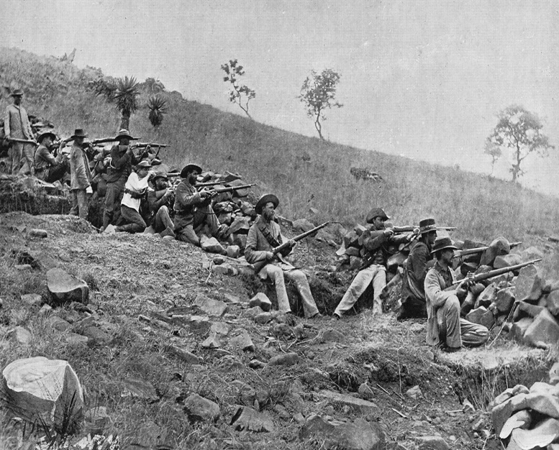
- Identify the group of people at war, and name the war shown above

- State the main event of Boer War

