STRAND 2 : LIVING TOGETHER
SUBSTRAND: 2.1 ORGANISM AND THE ENVIORNMENT
LEARNNG OUTCOME: EXAMINE POPULATION ATTRIBUTES, GROWTH AND REGULATION.
LESSON NO: 49
ESTIMATION OF POPULATION SIZE
There are some points to note when taking samples:
1. sample size must represent the population.
2. samples must be taken over the range of the population. 3. many samples must be taken.
METHODS OF TAKING POPULATION SAMPLES
1. Direct count – are used for small population, this method involves counting the individuals of the population directly.
2. Mark and recapture – used for populations that are highly motile eg turtles and bird. The individuals are captured, marked and released to the environment, at a later date, another sample is caught and the number of marked samples are counted.
The size of the population is estimated using the formula:
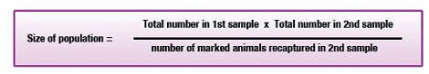
3. Transects – this is a line marked out with string which is stretched across a range of the population. It is divided into intervals of known distance. Percentage cover is estimated by the following formula
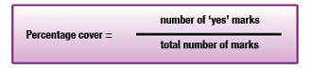
4. Quadrats – is a sample of known area within which all the species present are counted. To use this method, mark out on the area to be sampled the different places where the quadrat is to be placed.
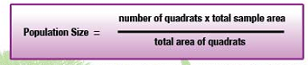
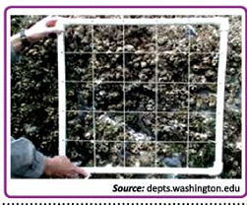

STRAND 2 : LIVING TOGETHER
SUBSTRAND: 2.1 ORGANISM AND THE ENVIORNMENT
LEARNNG OUTCOME: EXAMINE POPULATION ATTRIBUTES, GROWTH AND REGULATION.
LESSON NO: 50
COMMUNITES – Is the group of all plants and animals living in an area within an easily recognized boundary.
a. Producers – are made of mainly green plants, they make their own food by the process of photosynthesis.
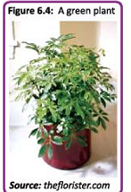
These are some adaptive features of the plants that help them to photosynthesize:
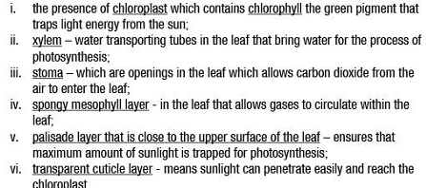

b. Consumers – they are organisms depend on other organisms for food.
Some important consumers are:
1. Herbivores – are consumers that eat plant tissues like leaves, bark, and plant sap. Example are cows and goats.
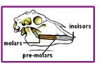
2. Carnivores – are consumers that feed on other animals. Features in carnivores includes: The presence of sharp canines for tearing flesh, having sharp incisor teeth for cutting food and molars that grinds food. Example dogs.
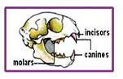
3. Omnivores – they are organisms that feed both on plants and animals examples Humans.
4. Decomposers – are organisms that help to break dead plant and animal materials. Examples are bacteria and fungi.
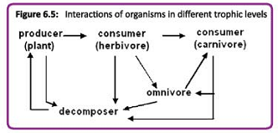
STRAND 2 : LIVING TOGETHER
SUBSTRAND: 2.1 ORGANISM AND THE ENVIORNMENT
LEARNNG OUTCOME: EXAMINE POPULATION ATTRIBUTES, GROWTH AND REGULATION.
LESSON NO: 51
COMMUNITY RELATIONSHIP
The feeding relationship in a community can be shown by using a diagram known as a food chain.
Example :1 the arrow means eaten by:
FOOD WEB – is made up of many interacting food chain.
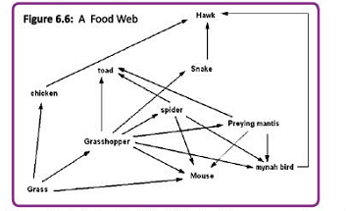
COMMUNITY RELATIONSHIPS SUMMARY TABLE
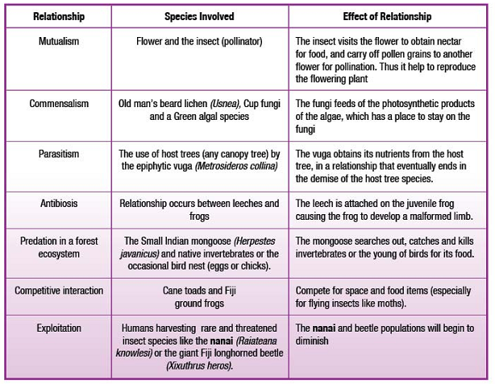
STRAND 2 : LIVING TOGETHER
SUBSTRAND: 2.1 ORGANISM AND THE ENVIORNMENT
LEARNNG OUTCOME: EXAMINE POPULATION ATTRIBUTES, GROWTH AND REGULATION.
LESSON NO: 52
Tides – the daily rise and fall in sea level that occurs twice a day. This tidal movement is the result of the interplay of the earth, moon and sun as the moon revolves around the earth.
-The gravitational forces of these components influence the body of water on the earth creating tides.
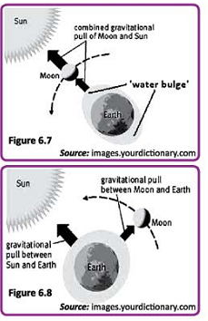
CONDITIONS OF THE THE INTER TIDAL ZONE
ABIOTIC CONDITIONS
1. Tempertaure - oceans have relatively stable environmental conditions.
2. Salinity- on hot days, evaporation from tidal pools may result in an increase in salinity, while on rainy days, tidal pools may become diluted decreasing the salinity.
3. Wave actions – waves tear plants and animals found at the inter-tidal zones.
ADAPTATIONS
1. Structural – the inter tidal terrestrial organisms have a variety of structural adaptations like the presence of shells, exoskeleton that helps reduce water loss.
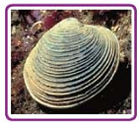
2. Behavioral – this adaptation involves movement or action. At high tide these organisms will crawl in search for food but as low tide approaches, they move under the rocks.

3. Physiological – this adaptation involves the internal functions of cells and organs. Some species of limpets and chitons can survive water loss up to 70%.
STRAND 2 : LIVING TOGETHER
SUBSTRAND: 2.1 ORGANISM AND THE ENVIORNMENT
LEARNNG OUTCOME: EXAMINE POPULATION ATTRIBUTES, GROWTH AND REGULATION.
LESSON NO: 53
ECOSYSTEM
-All communities and their environment make up the ecosystem. Ecosystem vary in size from a small aquarium to the large rainforest.
- the function of the ecosystem is determined by these processes:
1. Energy flow 2. Mineral cycles
Ecological pyramids- are made up of trophic levels of a food chain. The producer must always be the base of the pyramid followed by the herbivores and the carnivores.
3 types of pyramids
1. pyramid of numbers- shows the number of organisms present at each trophic level.

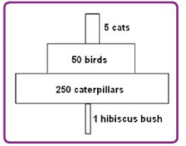
2. Pyramid of biomass- shows the amount of biomass at each trophic level.
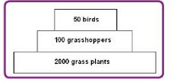
3. Pyramid of Energy – shows the amount of energy at each trophic level. It is assumed that only 10% of the energy is passed to the next trophic level.
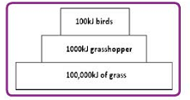

YEAR 11 BIOLOGY
WEEK 4 WORKSHEET

1. Using the mark-recapture method, the population size of wild cats on Lomawai Island was estimated to be 280. The area of the Island is 10 km².
(i) Calculate the population density of wild cats on Lomawai Island.

(ii) State one way of controlling the wild cat population.

(iii) Why would the quadrat method not be suitable for estimating the cat population.

2. (i) Draw a food chain of three trophic levels from a dalo plantation.
(ii) State the difference between competition and predation.
3. Organisms that are able to interbreed and produce fertile offspring belong to the same
A. species. B. population.
C. community. D. ecosystem.
4. An organism that has a segmented body and hydrostatic skeleton belongs to phylum
A. Mollusca (snails). B. Annelida (earthworms).
C. Platyhelminthes (flatworms). D. Arthropoda (insects).
5. The diagram below summarises the different feeding patterns in a community. Use the information given and your knowledge to answer the questions that follow.
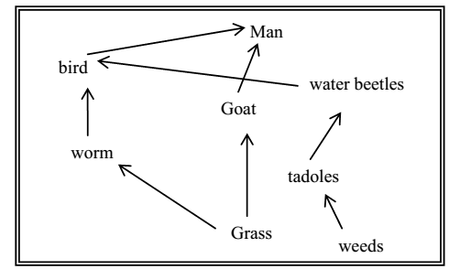
(i) What name is used to describe the feeding relationships shown above?
(ii) How many possible food chains are shown in the diagram?

