REVISION WORKSHEET(WEEK 10)
YEAR 10-SOCIAL SCIENCE
STRAND 3 - PLACE AND ENVIRONMENT
SECTION A Multiple-Choice Question
Circle the letter of the best answer.

1. Fiji’s climate is best described as

A. Mediterranean climate
B. Tropical climate
C. Monsoon climate
D. Autumn climate

2. Which one of the following can be best regarded as a physical factor?

A. Capital
B. Landform
C. Machinery
D. Transportation

3. Which one of the following is an example of coral island in Fiji?

A.Vanua Balavu
B. Kabara
C. Kadavu
D. Nukulau

4. Which of the following human activity has a positive effect on the envonment?

A. mining
B. burning
C. afforestation
D. deforestation.

5. The increase in the use of machinery in a factory may lead to

A. unemployment.
B. loss of equipment.
C. increase in labour.
D. lack of manpower training.

6. Which of the following factors pushes people away from rural areas?

A. Job availability
B. Lack of Services
C. Higher Education
D. Availability of services

7. Anticyclones is associated with

A. fine weather
B. rainy weather
C. wind and rain
D. cloudy and rainy weather

8. When people migrate by choice it is known as?

A. internal migration
B. voluntary migration
C. temporary migration
D. international migration

9. Vertical expansion of buildings in most towns and cities is due to

A. lack of space
B. urban to rural drift
C. decreasing population
D. increasing number of births

10. An important factor that influences the location of a manufacturing industry is?

A. pollution
B. raw materials
C. natural disasters.
D. demand for the product

SECTION B SHORT ANSWERS

(i) Give two reasons why rice is grown mostly on the wet side of the country.
____________________________________________________________________________________________________________________________________________________________

(ii) Discuss two activities by which a country can control its population growth.
__________________________________________________________________________________________________________________________________________________________________________________________________________________________________________
(iii) Explain why a piece of land is left fallow in shifting cultivation.
__________________________________________________________________________________________________________________________________________________________________________________________________________________________________________

(iv) Discuss one purpose of the Occupational Health and Safety (OHS) regulations in a workplace.
__________________________________________________________________________________________________________________________________________________________________________________________________________________________________________

(v)Identify two pull factors of rural to urban migration.
____________________________________________________________________________________________________________________________________________________________

SECTION C RESOURCE INTERPRETATION
i. Use the photograph below and your knowledge to answer the questions that follow.

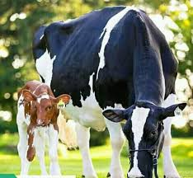

Source: https://www.google.com/search?q=dairy

(a) Name the type of farming shown in the resource above.
______________________________________________________________________________

(b) Describe a negative environmental effect of the type of farming shown.
____________________________________________________________________________________________________________________________________________________________

(c) State a factor that affects the operation of the industry shown in the Resource.

ii. Use the resource below and your knowledge to answer the question that follows.

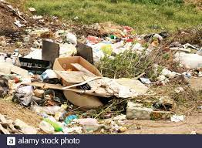

(a)Identify the human activity that has resulted in the above photograph.
______________________________________________________________________________
(b)From the resource given above explain how the above environmental problem is caused by urbanization
____________________________________________________________________________________________________________________________________________________________
(c)Explain one way in which the above problem affects marine life?
__________________________________________________________________________________________________________________________________________________________________________________________________________________________________________

SECTION D PARAGRAPH WRITING

Choose any industry of your choice that you have studied this year and in a paragraph discuss the following:
- location of the industry
- method of farming
- two problems faced by the industry
- One way in which government can assist the industry.

____________________________________________________________________________________________________________________________________________________________________________________________________________________________________________________________________________________________________________________________________________________________________________________________________________________________________________________________________________________

SECTION E MAPPING (5 marks)
Use the map of Fiji given to locate and name the following features:

(a) Capital City Of Fiji (b) Salad Bowl Of Fiji
(c) The deepest river (d) The biggest bay (e) Fiji’s old capital
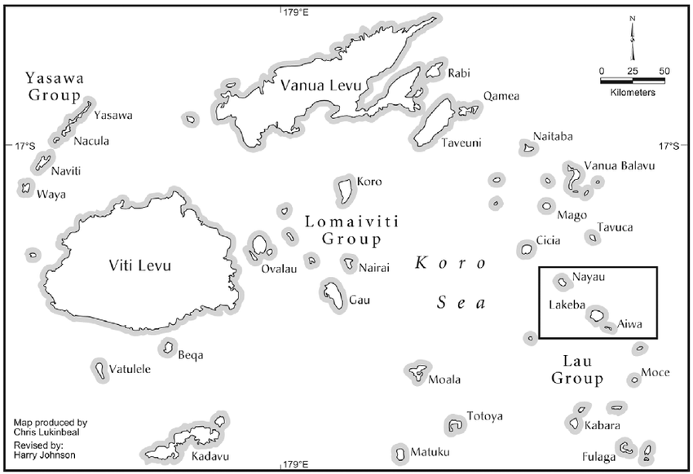
KEY :( Example)
(Note: 1. you need to have a KEY 2.You will locate in the map and write your answers in the key,3.There are two sections of a Key: On your left you will indicate the symbol used in the map as your answers and on the right you will write the question.
KEY:
(Symbol used in the map)- Description (Question)
1. | ..
2.
3.
4.
5.

