YEAR 10 HOME ECONOMICS

LESSON NOTES

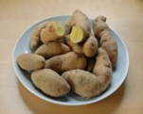
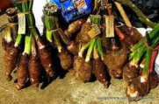
WEEK 7
LESSON 44
STRAND: HEC 10.2 FOOD AND NUTRITION
Sub Strands: HEC 10. 2.2 What is Food
CLO: HEC 10.2.2.1 Demonstrate an understanding of Commonly used foods – ROOT CROPS

DEFINITION:
- Root vegetables are plant roots used as vegetables. ‘Root’ means any underground part of a plant.

- Root crops/ vegetables are cultivated chiefly for their edible roots, e.g. the beet, turnip, carrot, and parsnip.

- Local root crops are dalo(taro), dalo- ni -tana, cassava, yams(different varieties, ), kumala etc.,

- All root crops have large water content and grow best in deeply cultivated soil in cool, overcast weather when the plant's loss of water through transpiration is lowest.

FOOD VALUE
Most root crops are rich in
- complex carbohydrates
- dietary fibre
- beta carotene (a Vitamin A equivalent nutrient), Vitamin C, and Vitamin B6.

COOKING AND SERVING ROOT CROPS:

NO | COOKING | SERVING
1 | Cooking root vegetables correctly enables most of the water soluble minerals and vitamins B and C to be retained | -eaten as accompaniments for most savory dishes at meal times.
2 | Baked/boiling root crops in their skins retain most of the vitamins.
3 | They can also be processed to make starch and flour which can be used in puddings and to thicken soups and stews. (Starch is also used for improving texture of white cotton garments.)

ACTIVITY:
- Why is cooking root crop in their skin important?

- Identify two food values of root crops.

- State two ways of cooking and serving root crops.

LESSON 45

STRAND: HEC 10.2 FOOD AND NUTRITION
Sub Strands: HEC 10. 2.2 DIGESTION, ABSORPTION AND UTILISATION OF FOOD
CLO: HEC 10.2.2.1
      - Define the terms: digestion and absorption
- Identify the parts of the human digestive system
Definition:
Digestion refers to the breakdown of food into smaller pieces that can be absorbed into the bloodstream.
Absorption is the process by which the products of digestion pass through the walls of the small intestine or digestive tract into the bloodstream.
PARTS OF THE HUMAN DIGESTIVE SYSTEM:
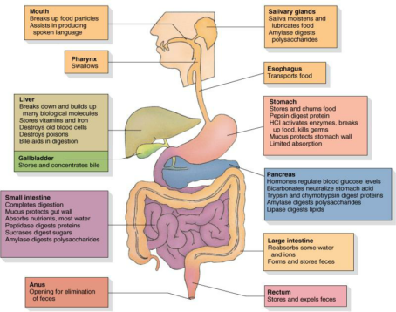

ACTIVITY
- What is digestion?

- Find out another name for the following:
- Oesophagus
- Digestive system
- Explain the presence of mucus in the stomach.

- Identify and name the organ where each of the following processes takes place.
- Food is mixed with gastric juice and becomes acidic as a result.
- Waste matter is held before it is passed out of the body as faeces.

LESSON 46

STRAND: HEC 10.2 FOOD AND NUTRITION
Sub Strands: HEC 10. 2.2 DIGESTION, ABSORPTION AND UTILISATION OF FOOD
CLO: HEC 10.2.2.1
- Explain how food is digested at each stage of digestion.
- Identify the simplest forms the nutrients are broken down into for absorption.
PHYSICAL AND CHEMICAL BREAKDOWN OF FOOD

Parts of digestive system | Physical Change | Chemical change
MOUTH | - Teeth tear, rip and grind food into tiny pieces small enough to swallow.  - Tongue pushes the food round the mouth and down the throat.  - Salivary glands produce saliva to moisten food and make it easy to swallow. | Protein :none  Fat: none  Carbohydrate: salivary amylase produced by salivary glands converts some starch to maltose.
OESOPHAGUS | NONE | NONE
STOMACH | - Food enters the stomach via the sphincter muscle at the top.  - Strong muscle waves move the food around and help it down and mix with gastric juices and mucus produced in the stomach.  - The broken food is referred to as chyme. | Protein: pepsin starts the breakdown of protein into smaller chains of amino- acids called peptides.  Fat: none  Carbohydrate: Hydrochloric acid produced by stomach stops the action of salivary amylase and helps pepsin to work. Food stays in the stomach for about 4-5 hours.
DUODENUM | None | The chyme is mixed with bile from the gall bladder and pancreatic juice from the pancrease. Bile neutralizes the acid and stops the action of pepsin.  Protein: Contains trypsin which starts to break protein in smaller parts.  Fat: Food is mixed with bile and pancreatic juice. Fats continue to be broken down by the action of lipase  Carbohydrate: pancreatic amylase breaks down undigested starch to maltose.
SMALL INTESTINE | NONE | Protein: Erepsin converts peptones to amino acids to complete protein digestion.  Fat : further broken down by lipase. Carbohydrate: Maltase breaks down maltose to glucose. Invertase breaks down sucrose to glucose and fructose. Lactase breaks down lactose to glucose and galactose.

ACTIVITY
1.State the physical function of the mouth.
2. Explain one chemical change that takes place in the stomach during digestion.
3.What is chyme?

